VN-LiteWaste: A Lightweight Attention-Enhanced CNN for Household Waste Classification
H.-Ngan NGUYEN-THI ¹, Q.-Hai NGUYEN ¹, V.-Diep NGUYEN ¹, T.-Phuc NGUYEN ¹, A.-Thuan LUU ¹, X.-Trang PHAN-THI ^{1*}
¹ School of Digital Technology and Artificial Intelligence, Nam Can Tho University, 168 Nguyen Van Cu Street, An Binh Ward, Can Tho City, Vietnam.
{ngan223845@student.nctu.edu.vn,nhakhoi@nctu.edu.vn}
Abstract. Household waste misclassification remains a pressing environmental challenge in Vietnam, where the Environmental Protection Law 2020 mandates the segregation of household solid waste into three categories at source, with enforcement beginning January 1, 2025. While deep learning has demonstrated strong potential for automated waste classification, existing approaches either rely on heavyweight architectures unsuitable for resource-constrained deployment or adopt material-based taxonomies incompatible with Vietnamese legal requirements. This study proposes VN-LiteWaste, a lightweight CNN built upon Residual Separable Convolution blocks integrated with SimAM attention and Large Kernel Attention, trained from scratch on 15,515 images with labels explicitly remapped to three legal groups defined in Article 75. A dedicated training pipeline combining sub-class balanced oversampling, Focal Loss, and Mixup augmentation was employed to mitigate the severe class imbalance introduced by the legal remapping process. VN-LiteWaste achieved 95.24% test accuracy and a macro F1-score of 0.90 with only 1,827,907 parameters, outperforming VGG16 (94.41%), EfficientNetB0 (94.67%), and MobileNetV2 (92.86%) baselines trained on the identical dataset. Upon TFLite FP16 conversion, the model occupies 3.48 MB at 50.4 FPS on CPU, providing a strong computational foundation for future mobile and edge deployment.
Keywords: Waste Classification; Lightweight CNN; Attention Mechanism; Vietnamese Environmental Law; Edge Deployment
- Introduction
The rapid acceleration of urbanization has placed mounting pressure on waste management systems worldwide. According to the United Nations Environment Programme (UNEP, 2024), global municipal solid waste generation currently reaches approximately 2.3 billion tons annually and is projected to increase to 3.8 billion tons by 2050. This trend poses increasingly severe environmental and public health challenges, particularly in developing countries where waste treatment infrastructure often struggles to keep pace with urban growth.

Vietnam represents a particularly relevant case in this context. Although public awareness regarding source-separated waste sorting has improved considerably, the studies report that only approximately 30% of Vietnamese households practice waste sorting correctly and consistently (VietnamNet, 2024), with the primary barrier being difficulty in distinguishing between categories rather than lack of awareness. This challenge has become increasingly important following the enactment of the Environmental Protection Law 2020, which mandates household waste separation into three categories at source starting from January 1, 2025 (National Assembly of Vietnam, 2020). In addition, Decree No. 45/2022/ND-CP introduces administrative penalties ranging from VND 500,000 to VND 1,000,000 for non-compliance with waste sorting regulations (Government of Vietnam, 2022). Consequently, waste segregation in Vietnam has shifted from a voluntary environmental practice to a legally enforceable responsibility.
Despite these regulatory efforts, households continue to encounter practical difficulties in distinguishing between waste categories due to the wide variety of materials and products encountered in daily life. Raising awareness alone may therefore be insufficient to ensure effective compliance. Instead, accessible decision-support tools capable of providing real-time guidance are needed to assist citizens in making correct waste sorting decisions. Advances in artificial intelligence offer a promising solution, with prior work demonstrating the feasibility of AI-based environmental tools in the Vietnamese context (Anh-Khoi et al., 2024). By capturing an image of a waste item using a smartphone, users could receive immediate recommendations aligned with legal requirements, thereby reducing cognitive burden and improving sorting accuracy.
Existing deep learning approaches for waste classification, however, exhibit several limitations when applied to the Vietnamese context. First, most international studies employ material-based taxonomies, such as plastic, glass, or metal, which are inconsistent with the three-category framework mandated by Vietnam's Environmental Protection Law. Second, many models achieving high classification accuracy rely on computationally intensive architectures with tens or even hundreds of millions of parameters, limiting their applicability on resource-constrained devices such as smartphones and embedded systems. Third, the process of remapping material-based labels into legally defined categories introduces severe class imbalance, a challenge that has received limited attention in previous studies.
Motivated by these gaps, this study proposes VN-LiteWaste, a lightweight convolutional neural network designed specifically for household waste classification under Vietnam's legally mandated three-category taxonomy. The model is trained from scratch to better adapt to the characteristics of waste imagery while maintaining suitability for deployment on resource-constrained devices.
The main contributions of this study are threefold:
- A legal-aware label remapping methodology is proposed to align a large-scale international waste dataset with Vietnamese waste-sorting regulations, accompanied by an imbalance mitigation pipeline designed to address the severe class distribution shift introduced by the remapping process.
- A lightweight CNN architecture integrating Residual Separable Convolution, SimAM attention, and Large Kernel Attention is developed to achieve competitive classification performance while maintaining fewer than two million parameters.
- A computational efficiency analysis is conducted to evaluate the deployment readiness of the proposed model through TensorFlow Lite FP16 conversion, providing evidence for future mobile and edge-device implementation.
- Related Work
In recent years, deep learning research on waste image classification has shifted from heavyweight pretrained architectures toward lightweight designs suited for practical deployment. The literature can be organized into three main streams.
  - Transfer Learning Approaches
Early work demonstrated the feasibility of AI-assisted waste sorting through community-facing applications. Prasad et al. (2024) deployed a VGG16-based classifier on a web platform in Malaysia, achieving 77.62% accuracy across 12 waste categories on a dataset of 15,497 images. Although the system incorporated practical features such as disposal guidance and recycling center localization, VGG16's 138 million parameters result in slow inference and high memory consumption, rendering it unsuitable for mobile or embedded deployment. To improve computational efficiency, Gurcan and Soylu (2025) conducted a systematic comparison of 14 pretrained CNN models, identifying MobileNetV2 as a strong performer at 96.95% accuracy. However, this result was obtained on a purpose-built dataset under controlled conditions without evaluating deployment readiness on resource-constrained hardware.
  - Lightweight Architecture Design and Edge Deployment
Recognizing the limitations of direct transfer learning, Yin (2025) proposed Lite-ResNet — a ResNet18 variant reducing the parameter count to 5.62 million — achieving 91.2% accuracy on the TrashNet benchmark (Thung & Yang, 2016). TrashNet, however, comprises only 2,527 images across 6 categories under uniform laboratory conditions, raising concerns about generalizability (Thung & Yang, 2016). Accuracy degraded notably on visually similar categories, recording 82.4% for plastics and 80.0% for miscellaneous waste. At the opposite end of the complexity spectrum, Verber et al. (2026) introduced CustomNet — a hybrid ensemble of ResNet-50, EfficientNet-B0, and MobileNetV3 fused through multi-head self-attention — achieving 97.79% accuracy across 10 categories. Despite successful deployment on NVIDIA Jetson Orin Nano, the model retains 40.3 million parameters, limiting practical scalability.
These findings reveal a persistent trade-off: models achieving high accuracy are computationally prohibitive, while lightweight models are validated only on small-scale laboratory datasets.
  - Waste Classification in the Vietnamese Context
Research directly addressing the Vietnamese regulatory context remains limited. Do and Vuong (2026) proposed a YOLOv8-based system classifying household waste into three groups aligned with Vietnam's Environmental Protection Law 2020, achieving mAP@0.5 of 0.915 with a deployment size of 6.2 MB. This work is the closest precedent in terms of legal alignment; however, YOLOv8 is an object detection architecture rather than a pure image classifier, and the dataset used was limited in scale and diversity. Furthermore, no existing study has addressed the specific class imbalance arising when material-based labels are collapsed into legal groups — where 9 of 12 original classes merge into a single dominant category.
Motivated by these gaps, this study proposes VN-LiteWaste: the first lightweight CNN trained from scratch with labels explicitly aligned to Vietnamese legal requirements, supported by a purpose-designed imbalance mitigation pipeline. The system design, model architecture, and experimental results are detailed in Sections 3, 4, and 5 respectively.
- Dataset and Preprocessing
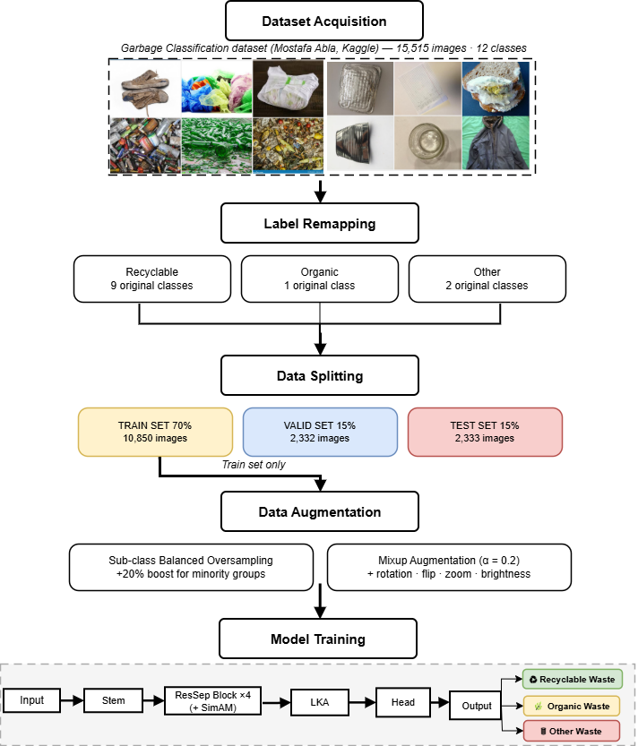
Fig 1. Overall Research Workflow of the Proposed VN-LiteWaste System.
As illustrated in Fig. 1, the proposed system follows five sequential stages, each of which is described in detail in the following subsections.
  - Dataset Acquisition
The Garbage Classification dataset (Mohamed, 2021) was adopted as the primary data source, comprising 15,515 images distributed across 12 material-based categories: paper, cardboard, biological, metal, plastic, green-glass, brown-glass, white-glass, clothes, shoes, batteries, and trash. The dataset was constructed primarily through web scraping with targeted keyword searches designed to approximate real-world waste appearances — for instance, the biological category includes images of rotten vegetables, rotten fruits, and food remains, while the clothes and shoes categories predominantly contain images of items in normal condition rather than discarded state. Images span diverse visual conditions including varied backgrounds, lighting angles, and object orientations, providing greater ecological validity than controlled laboratory benchmarks such as TrashNet (Thung & Yang, 2016), which comprises only 2,527 images captured against uniform white backgrounds. Representative samples from each category are shown in Figure 2.
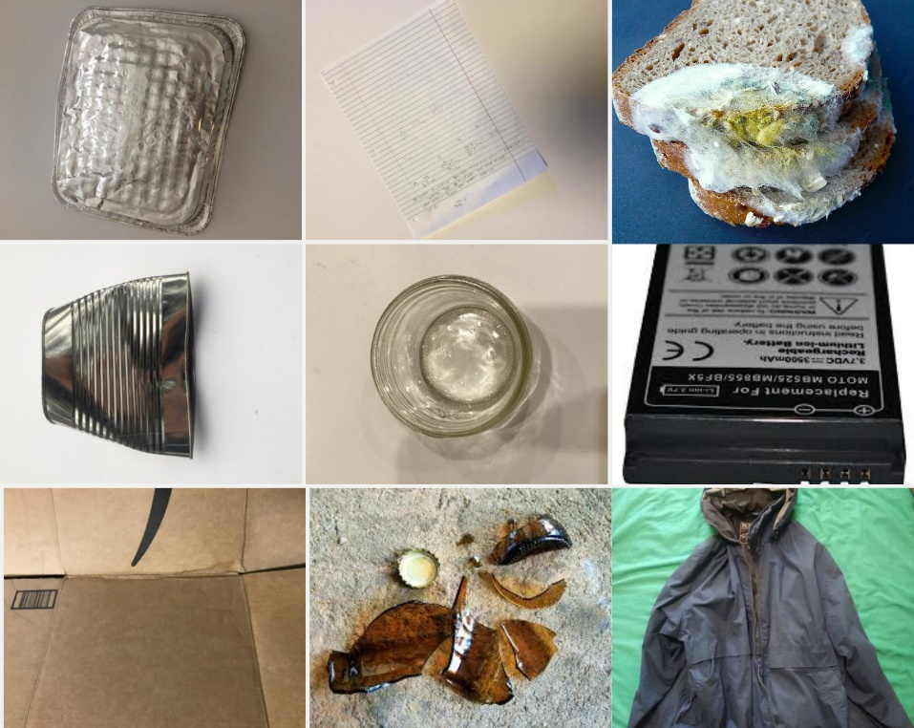
Fig 2. Representative samples from the Garbage Classification dataset.
  - Label Remapping
Since the 12 original categories are organized by material composition rather than waste management practice, they are incompatible with Vietnamese waste regulations. Pursuant to Article 75, Clause 1 of the Environmental Protection Law 2020 (National Assembly of Vietnam, 2020), a static mapping table was constructed to remap all 12 classes into three legally defined groups, as summarized in Table 1.
Table 1. Label remapping scheme and image distribution across three legal groups.

Legal Group | Original Classes | Classes | Images | %
Recyclable | cardboard, paper, plastic, metal, brown-glass, green-glass, white-glass, clothes, shoes | 9 | ~13,112 | 84.5%
Other | battery, trash | 2 | ~1,398 | 9.0%
Organic | biological | 1 | ~985 | 6.5%
Total |  | 12 | 15,515 | 100%

The Recyclable group aggregates nine original classes and accounts for 84.5% of total images, while Organic represents only 6.5% — an imbalance ratio of 13.3× that is a direct structural consequence of legal grouping rather than natural data distribution. This asymmetry necessitates the dedicated mitigation strategies described in Section 5.1.
  - Data Splitting
The dataset was divided into training (70%), validation (15%), and test (15%) partitions using stratified splitting on the 12 original classes, ensuring proportional representation of all original categories in each partition, as shown in Figure 4. The test set was strictly isolated throughout training and evaluated only once upon completion to ensure unbiased performance estimation. The training, validation, and test sets comprised 10,850, 2,332, and 2,333 images respectively.
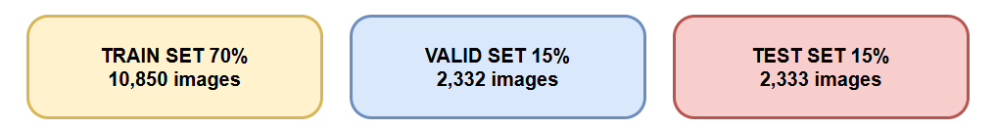
Fig 3. Dataset Splitting Strategy (70% Training, 15% Validation, and 15% Test Sets).
- Theoretical Background
This section presents the theoretical foundations of the three core components integrated into the proposed VN-LiteWaste architecture: Residual Separable Convolution, SimAM attention, and Large Kernel Attention.
  - Residual Separable Convolution
Standard convolution applies a K × K filter across all C input channels simultaneously, requiring K² × C × N parameters for N output channels. Depthwise Separable Convolution, introduced by Zhang et al. (2018), decomposes this operation into two sequential steps: a depthwise convolution applying a single K × K filter per input channel (K² × C parameters), followed by a pointwise convolution mixing channel information via a 1 × 1 filter (C × N parameters). The total parameter count becomes K² × C + C × N, yielding a reduction ratio of:
$R=1/N+1/K²$ (1)
For K = 3 and N = 256 — representative values in the proposed architecture — this corresponds to a reduction of approximately 9×, enabling substantially fewer parameters without sacrificing feature representation capacity.
The residual shortcut connection, introduced by He et al. (2016), adds the block input directly to its output via an identity mapping or a 1 × 1 projection convolution when dimensions differ. This skip connection addresses the vanishing gradient problem by providing an unimpeded gradient pathway during backpropagation, enabling stable training at greater network depth than would otherwise be feasible.
  - SimAM: Simple Attention Module
SimAM derives attention weights from a neuroscience-inspired principle: neurons that stand out from their local context — exhibiting high energy contrast relative to their spatial neighborhood — are assigned higher importance (Yang et al., 2021). Formally, the energy function for neuron x is defined as:
$e\left(x\right)=\left(x-μ\right)²/\left(4\left(σ²+λ\right)\right)+0.5$ (2)
where μ and σ² denote the spatial mean and variance of the feature map computed over all spatial locations, and λ = 10⁻⁴ is a regularization constant preventing division by zero. The attention weight is subsequently obtained as:
$ã=sigmoid\left(-e\left(x\right)\right)$ (3)
and applied element-wise to the feature map. A distinguishing property of SimAM is that it introduces zero learnable parameters: attention is computed entirely from the statistical properties of the input feature map at inference time, preserving the model's parameter budget entirely for feature extraction. This is in contrast to channel attention mechanisms such as SE-Net, which require two fully connected layers per block.
  - Large Kernel Attention
Convolutional neural networks traditionally employ small kernels (3 × 3 or 5 × 5) to limit computational cost, at the expense of a restricted receptive field. Large Kernel Attention (LKA), proposed by Guo et al. (2023), achieves a large effective receptive field through a three-stage decomposition that avoids the quadratic parameter growth of naive large-kernel convolution:
Stage 1 — Local context: A depthwise convolution with kernel size 5 × 5 captures fine-grained local spatial features.
Stage 2 — Long-range context: A dilated depthwise convolution with kernel size 7 × 7 and dilation rate d = 2 extends the spatial coverage to an effective receptive field of (7 − 1) × 2 + 1 = 13 pixels per dimension, capturing long-range dependencies without additional parameters.
Stage 3 — Channel mixing: A pointwise convolution (1 × 1) recombines channel information across the expanded spatial context.
The combined effective receptive field of the three-stage decomposition approximates 19 × 19 pixels, enabling the model to perceive overall object shape and global spatial layout. This is particularly important for distinguishing visually similar waste categories — such as transparent plastic bottles and white glass containers — where local texture alone is insufficient for reliable discrimination.
- Proposed Method
Unlike prior approaches that either adopt material-based taxonomies incompatible with Vietnamese regulations or rely on heavyweight pretrained architectures unsuitable for edge deployment, the proposed VN-LiteWaste system addresses both constraints simultaneously through three tightly integrated contributions: a legally-aligned imbalance mitigation pipeline, a purpose-designed lightweight architecture, and a training configuration optimized for minority class performance. Together, these components form a unified solution specifically designed for the Vietnamese three-category waste sorting mandate.
  - Data Balancing and Augmentation Strategy
Sub-class balanced oversampling was applied within each legal group to prevent dominant original classes from overshadowing smaller ones, distributing the target sample count equally across constituent original classes. The Recyclable group received 3,500 training samples, while the minority Organic and Other groups received a 20% boost of approximately 4,200 samples each to compensate for their limited original data volume — directly addressing the 13.3× imbalance ratio introduced by legal remapping.
Online augmentation was applied exclusively to the training set, including random rotation (±30°), horizontal flip, shift (±15%), zoom (±25%), and brightness variation (0.60–1.40×), improving robustness to real-world imaging conditions such as varying lighting and camera angles. Mixup augmentation (Zhang et al., 2018) with α = 0.2 was additionally applied at the batch level, generating convex combinations of training sample-label pairs to act as a strong regularizer and reduce overconfident predictions — particularly beneficial when training from scratch on an imbalanced dataset.
  - VN-LiteWaste Architecture
Although pretrained architectures such as MobileNetV2, EfficientNetB0, and VGG16 demonstrate strong performance on general benchmarks, their fixed feature distributions — learned from ImageNet — differ substantially from waste imagery, and their parameter counts (3.5M to 22.9M) exceed the lightweight target. VN-LiteWaste was therefore designed from scratch with two guiding principles: parameter efficiency for edge device deployment, and architectural specialization for the three-class Vietnamese waste classification task.
The architecture accepts 260 × 260 × 3 RGB images and produces a three-class probability vector through six sequential stages, as illustrated in Figure 4.
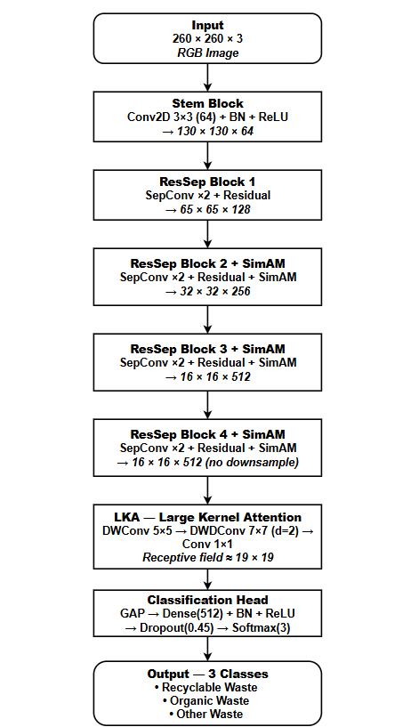
Fig 4. Detailed Architecture of the Proposed VN-LiteWaste Model.
The input resolution was determined by the network's downsampling schedule: after one stride-2 Stem convolution and three MaxPooling operations, the spatial dimension reduces to 16 × 16 — the minimum at which SimAM computes reliable spatial statistics. The network begins with a Stem block (Conv2D 3 × 3, 64 channels, stride 2) performing initial feature extraction at 130 × 130. Four ResSep blocks then progressively expand channel depth (128 → 256 → 512 → 512) while halving spatial dimensions at the first three stages; SimAM attention is integrated into blocks 2, 3, and 4, where deeper feature maps carry sufficient semantic content for meaningful spatial weighting, while block 4 preserves the 16 × 16 resolution for the subsequent LKA module. LKA expands the effective receptive field to approximately 19 × 19, enabling discrimination of visually similar materials such as transparent plastic and white glass where local texture alone is insufficient. The Classification Head comprising Global Average Pooling, Dense (512), Batch Normalization, ReLU, Dropout (0.45), and Softmax (3) produces the final output. The complete model contains 1,827,907 parameters, of which 1,816,131 are trainable.
  - Training Configuration
The model was trained for a maximum of 120 epochs with batch size 24 using AdamW (Loshchilov & Hutter, 2019) (weight decay = 1e-4) with a Cosine Decay learning rate schedule incorporating a 5-epoch linear warmup, peaking at 3×10⁻⁴. Focal Loss (Lin et al., 2017) with γ = 2.0 and label smoothing ε = 0.05 served as the training objective, concentrating gradient updates on hard misclassified samples — particularly effective given the severe class imbalance. EarlyStopping with patience of 25 epochs monitored validation accuracy and restored the best checkpoint automatically, with training converging at epoch 115 out of the maximum 120.
The combined effect of the three components described in Sections 5.1–5.3 constitutes the core technical contribution of this study: a cohesive pipeline that simultaneously addresses legal taxonomy alignment, class imbalance from label remapping, and parameter efficiency — three challenges that, to the best of our knowledge, have not been jointly addressed in prior waste classification work.
- Experiments and Results
  - Experimental Setup
All experiments were conducted on Kaggle Notebooks using two NVIDIA Tesla T4 GPUs (13,757 MB VRAM) with TensorFlow 2.19.0 and Python 3.12. For computational efficiency evaluation, TensorFlow Lite with float16 quantization was benchmarked on a CPU-only environment (Intel Xeon, single image, 200 runs following 20 warmup runs). Transfer learning baselines (VGG16, EfficientNetB0, MobileNetV2) were fine-tuned using standard two-stage transfer learning with categorical cross-entropy loss on the identical dataset and 70/15/15 split to ensure a fair comparison.
  - Evaluation Metrics
Model performance was assessed using four standard classification metrics computed on the held-out test set. Macro-averaging was applied throughout, assigning equal weight to each class regardless of sample support — a deliberate choice given the severe imbalance between the Recyclable group (83.1%) and the Organic group (6.3%).
Accuracy measures the overall proportion of correctly classified samples:
$Accuracy=\left(TP₁+TP₂+TP₃\right)/N$ (4)
where TPₖ denotes the number of true positives for class k and N is the total number of test samples.
Macro-averaged Precision quantifies the average ratio of correct positive predictions to all positive predictions across classes:
$Precision=\left(1/K\right)×ΣₖTPₖ/\left(TPₖ+FPₖ\right)$ (5)
Macro-averaged Recall measures the average ratio of correct positive predictions to all actual positives:
$Recall=\left(1/K\right)×ΣₖTPₖ/\left(TPₖ+FNₖ\right)$ (6)
Macro-averaged F1-score is the harmonic mean of Precision and Recall:
$F1=2×\left(Precision×Recall\right)/\left(Precision+Recall\right)$ (7)
where K = 3 is the number of classes, FPₖ and FNₖ denote false positives and false negatives for class k respectively. Macro-averaging was preferred over weighted averaging because the latter would inflate overall scores by over-representing the dominant Recyclable class, masking potential underperformance on the minority Organic and Other groups.
For computational efficiency evaluation, four additional metrics were recorded: model size on disk (MB), mean inference latency (ms) averaged over 200 consecutive single-image runs, p95 latency (ms) representing the 95th percentile of the latency distribution to characterize worst-case inference behavior, and throughput (FPS) defined as 1000 / mean latency. All inference measurements were preceded by 20 warmup runs to eliminate JIT compilation effects.
  - Overall Performance
VN-LiteWaste achieved 95.24% test accuracy with macro precision of 0.88, recall of 0.92, and F1-score of 0.90, exceeding the predefined 90% accuracy target. The consistency between validation accuracy (95.07%) and test accuracy (95.24%) — a gap of only 0.17 percentage points — confirms that the model generalizes well without overfitting. Figure 7 presents the training and validation loss and accuracy curves over 115 epochs, demonstrating stable convergence with no significant divergence between training and validation trajectories.
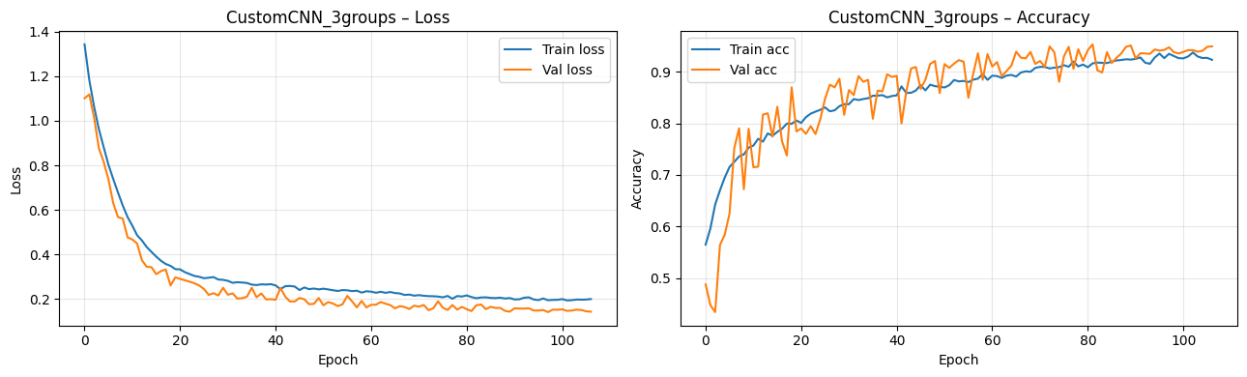
Fig 5. Training and Validation Loss and Accuracy Curves over 115 Epochs.
  - Comparative Results
To ensure a fair comparison, three pretrained architectures — VGG16, EfficientNetB0, and MobileNetV2 — were evaluated as self-run baselines on the identical dataset, split, and hardware environment. As shown in Table 2, VN-LiteWaste achieves the highest overall accuracy (95.24%) with the fewest parameters (1.83M) and the smallest deployment size (3.48 MB). Although EfficientNetB0 yields a marginally higher macro F1-score (92.28% vs. 90.00%), this difference is accompanied by nearly 3× more parameters and a deployment size of approximately 20 MB — nearly 6× larger than VN-LiteWaste after TFLite conversion. These results suggest that for deployment scenarios where storage and inference efficiency are constrained, VN-LiteWaste offers a more favorable balance between classification performance and computational cost than conventional transfer learning approaches.
Table 2. Comparison with self-run baselines on the same dataset and 70/15/15 split. Standard two-stage transfer learning with cross-entropy loss.
Model | Params | Size (MB) | Accuracy | F1 (macro)
VGG16 | 138M | ~528 | 94.41% | 91.74%
EfficientNetB0 | 5.3M | ~20 | 94.67% | 92.28%
MobileNetV2 | 3.4M | ~14 | 92.86% | 89.45%
VN-LiteWaste (Proposed) | 1.83M | 3.48 | 95.24% | 90.00%

  - Per-Class Analysis and Confusion Matrix
Table 3 presents per-class classification results on the test set. The model achieves an overall accuracy of 95.24% on 2,333 test samples. The Recyclable class achieves the highest F1-score of 0.97, indicating reliable identification of the dominant waste group. The Organic class, despite being the most underrepresented group with only 148 test samples originating from a single original class, achieves an F1-score of 0.90 — demonstrating that the combined sub-class oversampling and Focal Loss pipeline effectively prevents minority class underperformance. The Other class exhibits the lowest F1-score of 0.81, reflecting the visual heterogeneity of this group — battery and trash encompass highly diverse object appearances that can overlap with degraded recyclable materials.
Table 3. Per-class classification results on the test set.
Class | Precision | Recall | F1-score | Support
Other | 0.80 | 0.83 | 0.81 | 247
Recyclable | 0.98 | 0.96 | 0.97 | 1,938
Organic | 0.86 | 0.95 | 0.90 | 148
Macro average | 0.88 | 0.92 | 0.90 | 2,333
Accuracy |  |  | 0.95 | 2,333
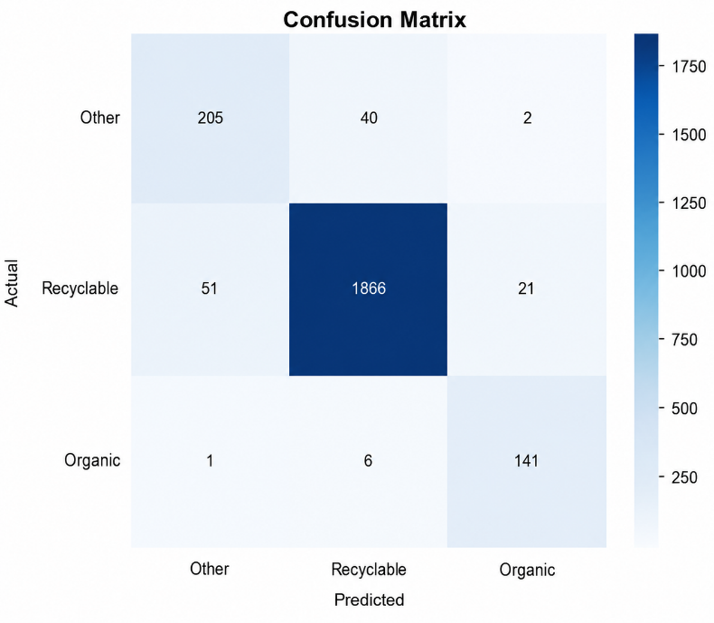
Fig 6. Confusion Matrix for Three-Class Vietnamese Waste Classification.
The confusion matrix in Figure 6 reveals the dominant error pattern: 51 Recyclable samples were misclassified as Other, and 40 Other samples were misclassified as Recyclable. This bidirectional confusion between the Recyclable and Other groups is attributable to the visual heterogeneity of the Other category — battery and trash encompass highly diverse appearances that can overlap with degraded or damaged recyclable materials. The Organic class exhibits minimal confusion with only 7 misclassifications out of 148 test samples (1 predicted as Other and 6 as Recyclable), confirming that organic waste possesses sufficiently distinctive visual features for reliable separation.
  - Computational Efficiency Analysis
To assess the deployment feasibility of VN-LiteWaste, computational efficiency metrics were measured before and after TensorFlow Lite FP16 conversion, as summarized in Table 4. TensorFlow Lite was selected because it is the standard runtime for on-device inference on Android and embedded systems, allowing the model to run directly on edge hardware without requiring cloud connectivity — essential for real-world deployment in Vietnamese households. The model requires 1.5007 GFLOPs per inference, with the 260×260 input resolution accounting for the slightly higher compute compared to standard 224×224 models. TFLite FP16 conversion reduced model size by 83.5% from 21.10 MB to 3.48 MB — smaller than YOLOv8n (6.2 MB) (Do & Vuong, 2026)— while maintaining accuracy within 0.04 percentage points and improving throughput from 11.8 to 50.4 FPS on CPU, exceeding the 25 FPS real-time threshold. These results establish a promising computational baseline for future edge device deployment.

Table 4. Computational efficiency before and after TFLite FP16 conversion (CPU, 200 runs).
Metric | Keras (.keras) | TFLite FP16
Parameters | 1,827,907 | 1,827,907
GFLOPs | 1.5007 | ~0.75*
Model size | 21.10 MB | 3.48 MB (−83.5%)
Mean latency | 84.53 ms | 19.86 ms (4.3× faster)
p95 latency | 89.27 ms | 20.82 ms
Throughput | 11.8 FPS | 50.4 FPS
Test accuracy | 95.24% | 95.20%

- Discussion
The results indicate that a lightweight CNN trained from scratch on a legally-aligned dataset can achieve classification performance competitive with pretrained transfer learning models while requiring substantially fewer parameters. VN-LiteWaste achieved 95.24% test accuracy with only 1.83M parameters, outperforming VGG16 (94.41%, 138M), EfficientNetB0 (94.67%, 5.3M), and MobileNetV2 (92.86%, 3.4M) on the identical dataset and split. Although EfficientNetB0 achieves a marginally higher macro F1-score (92.28% vs. 90.00%), it requires nearly 3× more parameters and a deployment size of approximately 20 MB — nearly 6× larger than VN-LiteWaste after TFLite conversion. This trade-off suggests that for deployment scenarios where storage and inference speed are constrained, VN-LiteWaste offers a more practical balance between accuracy and efficiency. More broadly, these findings support the proposition that purpose-designed lightweight architectures can be competitive with general-purpose transfer learning when the target task has a well-defined and constrained output space.
The integration of SimAM and LKA is expected to have contributed to feature discrimination, particularly for visually similar waste categories. SimAM assigns per-neuron attention weights based on local energy contrast at zero parameter cost, while LKA extends the effective receptive field to approximately 19 × 19, potentially improving the model's ability to perceive global object shape — a characteristic that may be beneficial when distinguishing materials such as transparent plastic and white glass where local texture alone is insufficient. The Organic class F1-score of 0.90 — achieved despite representing only 6.5% of the dataset — further suggests that the combined oversampling and Focal Loss pipeline effectively addresses the 13.3× class imbalance introduced by legal remapping. The class imbalance arising from legal label remapping has received limited attention in prior waste classification studies, and the proposed pipeline offers one replicable approach to this problem. It is noted that (Do & Vuong, 2026) reported lower detection performance for the organic category (mAP 0.873) using a YOLOv8-based approach on a different dataset and task formulation; while direct comparison is not straightforward given the methodological differences, the result is consistent with the hypothesis that end-to-end CNN training with dedicated imbalance mitigation may offer practical advantages for this classification task.
The generalizability of the results is limited in two respects. First, the dataset was assembled under relatively controlled visual conditions, and performance on images captured spontaneously by Vietnamese households — with cluttered backgrounds, inconsistent lighting, and partial occlusion — has not been evaluated. Second, inference benchmarking was conducted on cloud CPU hardware rather than physical edge devices, and the extent to which 50.4 FPS translates to mobile processors remains to be empirically confirmed.
These limitations directly motivate the primary directions for future development. In the near term, the most impactful contribution would be the collection of real-world waste images captured by Vietnamese users under natural household conditions, which would enable domain adaptation and significantly improve practical reliability. In parallel, physical deployment on entry-level Android smartphones and low-cost single-board computers — hardware accessible to the majority of Vietnamese households — is planned to validate inference performance in realistic settings. Further optimization through INT8 quantization and knowledge distillation targets a model size below 2 MB, which would allow embedding directly within mobile applications without additional downloads, a critical consideration for users in rural areas with limited connectivity. Together, these directions aim to evolve VN-LiteWaste from a research prototype into a practical, regulation-compliant waste sorting assistant deployable on the devices most Vietnamese citizens already own.
- Conclusion
This study proposed VN-LiteWaste, a lightweight convolutional neural network for household waste classification explicitly aligned with the three-category sorting mandate established by Article 75 of Vietnam's Environmental Protection Law 2020. A complete pipeline was designed and validated — encompassing legal label remapping, sub-class balanced oversampling, Focal Loss training, and TFLite FP16 conversion — covering the key stages from data preparation to deployment readiness.
The proposed model achieved 95.24% test accuracy and a macro F1-score of 0.90 with only 1,827,907 parameters. Among the self-run baselines trained on the identical dataset and split, VN-LiteWaste achieved the highest accuracy, surpassing VGG16 (94.41%), EfficientNetB0 (94.67%), and MobileNetV2 (92.86%) without requiring ImageNet pretraining. The Organic class, representing only 6.5% of the dataset, attained an F1-score of 0.90, demonstrating that the proposed imbalance mitigation pipeline reliably handles legally-induced class distribution asymmetry. Upon TFLite FP16 conversion, the model occupies 3.48 MB at 50.4 FPS on CPU — 43.9% smaller than the prior Vietnamese-context system (Do & Vuong, 2026) — providing a strong computational foundation for future mobile deployment.
It is acknowledged that the current study has not yet validated performance under real-world Vietnamese household conditions, nor has inference been benchmarked on physical edge devices. Future work will focus on three directions: first, collecting real-world waste images from Vietnamese households to evaluate and improve domain robustness; second, benchmarking inference on physical edge devices including entry-level Android smartphones and single-board computers; and third, exploring INT8 quantization and knowledge distillation to reduce model size below 2 MB, targeting ultra-constrained deployments in rural Vietnamese communities. Integration with continuous learning frameworks (Ngo-Ho et al., 2023; Ngo et al., 2024) could further enable incremental adaptation to new waste types without full retraining. By addressing these directions, VN-LiteWaste has the potential to evolve into a practical, regulation-compliant waste sorting assistant that supports Vietnamese citizens in meeting their legal sorting obligations through the devices they already own.

References
- UNEP. (2024). Global waste management outlook 2024: Beyond an age of waste. United Nations Environment Programme. https://www.unep.org/resources/global- waste-management-outlook-2024
- VietnamNet. (2024, June). Ministry identifies challenges in household solid waste management in Vietnam. https://vietnamnet.vn/en/ministry-identifies- challenges-in-household-solid-waste-management-in- vietnam-2315062.html
- Anh-Khoi, N. H., Thanh-Nam, T., Van-Linh, N., & Anh-Duy, N. (2024). Water Quality Inspection System for Mariners Using EKI’s Continuous Learning Algorithms. In International Conference on Smart Objects and Technologies for Social Good (pp. 218-230). Cham: Springer Nature Switzerland.
- National Assembly of Vietnam. (2020, November 17). Law on Environmental Protection No. 72/2020/QH14. https://vanban.chinhphu.vn/?pageid=27160&docid=202613
- Government of Vietnam. (2022, July 7). Decree No. 45/2022/ND-CP on administrative penalties for violations of environmental protection regulations. https://congbao.chinhphu.vn/van-ban/nghi-dinh-so- 45-2022-nd-cp-37540.html
- Gurcan, F., & Soylu, A. (2025). Automated waste classification for smart recycling: A multi-class CNN approach with transfer learning and pre-trained models. Environmental Technology & Innovation, 39, 104673. https://doi.org/10.1016/j.eti.2025.104673
- Prasad, R. K., Ghani, M. F. A., & Annamalai, S. (2024). An AI-based smart waste management system for community support. International Journal of Advanced Computer Science and Applications, 15(10). https://doi.org/10.14569/IJACSA.2024.0151009
- Yin, P. (2025). Application of lightweight CNN in garbage image classification. Computing, Performance and Communication Systems, 9(1), 65–72. https://doi.org/10.23977/cpcs.2025.090109
- Thung, G., & Yang, M. (2016). Classification of trash for recyclability status [CS229 Project Report]. Stanford University. https://github.com/garythung/ trashnet
- Verber, D., Grneva, T., & Dugonik, J. (2026). Image-based waste classification using a hybrid deep learning architecture with transfer learning and edge AI deployment. Mathematics, 14(7), 1176. https://doi.org/10.3390/math14071176
- Do, M. H., & Vuong, T. L. A. (2026). A new deep learning model to support people in classifying household waste in Vietnam. TEM Journal, 15(1), 867–875. https://doi.org/10.18421/TEM151-79
- Mohamed, M. (2021). Garbage classification (12 classes) [Dataset]. Kaggle. https://www.kaggle.com/datasets/ mostafaabla/garbage-classification
- He, K., Zhang, X., Ren, S., & Sun, J. (2016). Deep residual learning for image recognition. Proceedings of the IEEE Conference on Computer Vision and Pattern Recognition (CVPR), 770–778. https://arxiv.org/abs/1512.03385
- Yang, L., Zhang, R.-Y., Li, L., & Xie, X. (2021). SimAM: A simple, parameter-free attention module for convolutional neural networks. Proceedings of the 38th International Conference on Machine Learning (ICML), 139, 11863–11874. https://proceedings.mlr.press/v139/yang21o.html
- Guo, M.-H., Lu, C.-Z., Liu, Z.-N., Cheng, M.-M., & Hu, S.-M. (2023). Visual attention network. Computational Visual Media, 9(4), 733–752. https://arxiv.org/abs/2202.09741
- Zhang, H., Cisse, M., Dauphin, Y. N., & Lopez-Paz, D. (2018). mixup: Beyond empirical risk minimization. Proceedings of the 6th International Conference on Learning Representations (ICLR). https://openreview.net/forum?id=r1Ddp1-Rb
- Lin, T.-Y., Goyal, P., Girshick, R., He, K., & Dollár, P. (2017). Focal loss for dense object detection. Proceedings of the IEEE International Conference on Computer Vision (ICCV), 2980–2988. https://doi.org/10.1109/ICCV.2017.324
- Loshchilov, I., & Hutter, F. (2019). Decoupled weight decay regularization. Proceedings of the 7th International Conference on Learning Representations (ICLR). https://openreview.net/forum?id=Bkg6RiCqY7
- A. K. N. Ho, N. Ragot, J. -Y. Ramel, V. Eglin and N. Sidere (2013). "Document Classification in a Non-stationary Environment: A One-Class SVM Approach," 2013 12th International Conference on Document Analysis and Recognition, Washington, DC, USA, 2013, pp. 616-620, doi: 10.1109/ICDAR.2013.127.
- Ho, A. K. N. (2015). Méthodes de classifications dynamiques et incrémentales: application à la numérisation cognitive d'images de documents (Doctoral dissertation, Tours).
- Ngo-Ho, A. K., Bui, H. B., & Pham, V. T. (2023). Continuous learning for automatic identification of Oc Eo antique glass jewelry. In 2023 15th International Conference on Knowledge and Systems Engineering (KSE) (pp. 1-4). IEEE.

